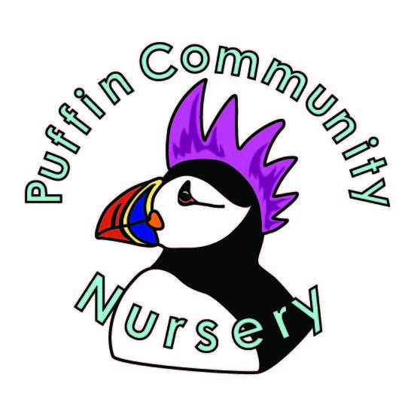

Privacy Notice

Puffin Community Nursery
Millwood centre, Nelson Row, Brighton. BN2 9AH
Tel: 01273 686687 E-mail: puffinnursery@yahoo.co.uk

Here at Puffin Community Nursery we respect the privacy of the children attending the Nursery and the privacy of their parents or carers.

What information do we collect and process?
We collect personal data about you and your child to provide care and learning that is tailored to meet your child’s individual needs. We also collect information in order to verify your eligibility for free childcare as applicable.

Personal details that we collect about your child include:
Your child’s name, date of birth, address, health and medical needs, development needs, and any special educational needs. We may also keep other information relating to your child such as details of any incidents or accidents.

Personal details that we collect about you include:
Your name, address, phone numbers, emergency contact details, and family details.
This information will be collected from you directly in the registration form.
If you apply for up to 30 hours free childcare, we will also collect your national insurance number and date of birth. Our legal basis for processing the personal information relating to you and your child is so that we can fulfil our contract with you and meet our legal obligations as a childcare provider. In some cases, we will require your specific consent, for example use of your child’s photographs in promotional literature.

Why we collect this information and the legal basis for handling your data
We use personal data about you and your child in order to fulfil the contractual arrangement you have entered into and meet our legal obligations as a childcare provider This includes using your data to:
- contact you in case of an emergency
- to support your child’s wellbeing and development
- to manage any special educational, health or medical needs of your child whilst at our setting
- to carry out regular assessment of your child’s progress and to identify any areas of concern
- to maintain contact with you about your child’s progress and respond to any questions you may have
- to process your claim for up to 30 hours free childcare (only where applicable)
- to keep you updated with information about the Nursery

With your consent, we will also record your child’s activities for their individual learning record. This may include photographs and videos. You will have the opportunity to withdraw your consent at any time, for images taken by confirming so in writing.

We have a legal obligation to process safeguarding related data about your child should we have concerns about their welfare. we also have a legal obligation to transfer records and certain information about your child to the school that your child will be attending.

Who we share your data with
In order for us to deliver childcare services we will also share your data as required with the following categories of recipients:
- Ofsted – during an inspection or following a complaint about our service
- the Local Authority (where you claim up to 30 hours free childcare as applicable)
- the government’s eligibility checker (as above)
- our setting software management provider (if applicable)
- the school that your child will be attending
we will also share your data if:
- we are legally required to do so, for example, by law, by a court or the Charity Commission;
- to enforce or apply the terms and conditions of your contract with us.
- to protect your child and other children; for example, by sharing information with social care or the police;
- it is necessary to protect our, or others, rights, property or safety

How is it held?
Your personal information is held securely either in hard copy format or electronically. We take security of your data seriously and we have internal policies and controls in place to ensure that it is not lost, misused or destroyed.

How long do we retain your data?
We retain your child’s personal data for up to 3 years after your child no longer uses our setting, or until our next Ofsted inspection after your child leaves our setting. Medication records and accident records are kept for longer according to legal requirements. Your child’s learning and development records are maintained by us and handed to you when your child leaves.
In some instances (child protection, or other support service referrals) we are obliged to keep your data for longer if it is necessary to comply with legal requirements

How do we use your personal information?
The personal information that we collect about you and your child is used only to provide appropriate care for them, maintain our service to you, and communicate with you effectively.

We will use the contact details you give us to contact you via phone, email, social media and post so that we can send you information about your child, our organisation and other relevant news and also so that we can communicate with you regarding payment of our fees.

Our legal basis for processing the personal information relating to you and your child is so that we can fulfil our contract with you and meet our legal obligations as a childcare provider. In some cases we will require your specific consent, for example use of your child’s photographs in promotional literature.

Who do we share your information with?
We will only share personal information about you or your child with another organisation if we:
- have a safeguarding concern about your child
- are required to by government bodies or law enforcement agencies
- engage a supplier to process data on our behalf (eg to take online bookings)
- have obtained your prior permission.

Your rights with respect to your data
You have the right to:
- request access, amend or correct your/your child’s personal data
- request that we delete or stop processing your/your child’s personal data, for example where the data is no longer necessary for the purposes of processing; and
- request that we transfer your, and your child’s personal data to another person

If you wish to exercise any of these rights at any time or if you have any questions, comments or concerns about this privacy notice, or how we handle your data please contact us. If you continue to have concerns about the way your data is handled and remain dissatisfied after raising your concern with us, you have the right to complain to the Information Commissioner Office (ICO). The ICO can be contacted at Information Commissioner’s Office, Wycliffe House, Water Lane, Wilmslow, Cheshire, SK9 5AF or ico.org.uk/

Please sign and date below to confirm that you have read this Privacy Notice and that you give your permission for us to contact you regarding relevant matters.

Signed: Date:
Name:

